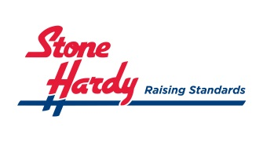
ENVIRONMENTAL STATEMENT

Stone Hardy recognises the need for sustainable development and continually aims to improve the environmental effect of its activities. To achieve this we will:-

Establish sound environmental management by:-

- Meeting of improving upon relevant legislative, regulatory and environmental practice.

- Developing objectives that target environmental improvements, and monitor performance by regular review

- Consider any environmental issues in the decision making process

- Developing a relationship with suppliers and contractors so that we all recognise our environmental responsibilities

- Education staff so that they carry out their activities in an environmentally responsible manner

Provide for effective us of resource by:-

- Promoting waste minimisation by recycling or finding other uses for by-products whenever economically viable

- Promoting the efficient use of resources, energy and fuel throughout the company’s operations

Co-operate with:-

- The communities in which we operate

- The government, regulatory bodies and other interested parties with the shared vision of being a good and trusted neighbour

