A SIMPLE GUIDE TO THOROUGH EXAMINATION AND TESTING OF LIFTS

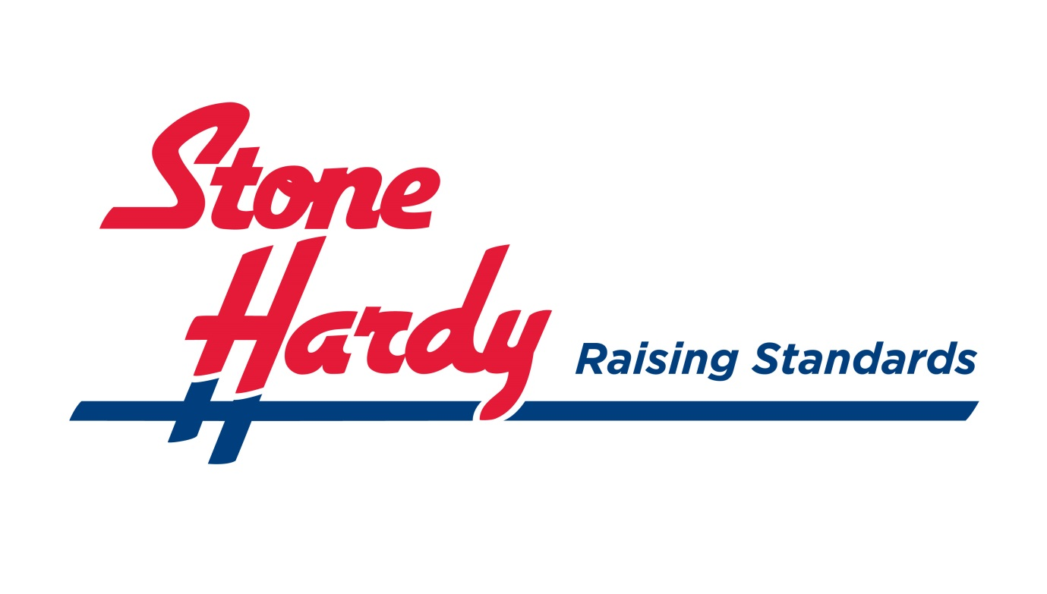

THOROUGH EXAMINATION AND TESTING OF LIFTS
SIMPLE GUIDANCE FOR LIFT OWNERS
Introduction
The Lifting Operations and Lifting Equipment Regulations 1998 (LOLER) introduced new requirement for the safe provision and use of lifting equipment. Regulation 9 of LOLER requires that all lifts provided for use in work activities are thoroughly examined by a competent person at regular intervals. This applies to lifts and hoists used to lift people or loads.
If you are a lift owner or someone responsible for the safe operation of a lift used at work, such as a facilities manager or supervisor, you are a “dutyholder” under LOLER. This means that you have a legal responsibility to ensure that the lift is thoroughly examined and that it is safe to use. (If you are the owner of a lift used primarily by members of the public, you may also find this guidance helps you to comply with more general health and safety legal duties under the Health and Safety at Work etc Act (1974).
This leaflet explains what you need to do to comply with the law.
STATUTORY THOROUGH EXAMINATION
Description
A Statutory Thorough Examination is not the same as a weight test or a service inspection, nor is it an MoT Test, although in many respects it is very similar. Many users wrongly believe that a service inspection and weight test is sufficient to satisfy the Regulations.
What constitutes a Statutory Thorough Examination has been broadly defined by the Regulations. Guidance has also been taken from the Health and Safety Executive and insurance companies.
Thorough Examination Key Requirements
- It must be carried out by a “Competent Person”.

- A Thorough Examination determines the overall condition of an item.

- It requires an in-depth investigation and should ensure the safety of operators, passengers and bystanders.

- It may well include inspection and testing.

- It requires an understanding of the correct functioning of the lift and of possible fault conditions. It therefore requires an understanding of how the equipment works.
- It requires an ability to recognise the signs of common forms of product misuse and its possible effect on lift safety.

- It needs the ability to diagnose early signs of failure.

- It might require an investigation of internal parts.

- It should be carried out as a separate exercise and must not be combined with any remedial work (HSE Book L113, Page 52, Section 348).
The results of a Statutory Thorough Examination must be fully documented, in line with the requirements laid down in Schedule 1 of the Regulations (Regulation 11, HSE Book L113).

Certain parallels may be drawn between a Statutory Thorough Examination and the statutory MoT test for a motor vehicle. It is useful to consider the two forms of examination and their similarities and difference.

Similarities

- They must both be thorough.

- A principal objective of the examination is to ensure continued safe operation of the equipment.

- Neither test is concerned with reliability, eg a burnt out alternator will not be an MoT failure.

- They are not concerned with subsequent rectification which may be carried out by any workshop of the owner’s choosing.

- Both are legal obligations.

Difference

- There is no pass or fail with a Statutory Thorough Examination.

THOROUGH EXAMINATION INTERVALS

Tail lift users need to ensure that Statutory Thorough Examinations are carried out on a lift at various stages during the life of the equipment:

- When put into service for the first time.

- When there have been exceptional circumstances that may have affected the safety of the lift, for example if the lift has been involved in an accident.

- On a regular basis throughout the life of the lift (see HSE Book L113, Page 48, Section 316).

There are two ways that the user can approach this.

EITHER

- Have a thorough examination programme drawn up for the tail lifts in use. The programme must be drawn up by a person with the necessary competence and it should identify and specify those parts of the lifting equipment that should be thoroughly examined.

OR

- Follow what is referred to as the “specified period approach” and have the lifts thoroughly examined at the intervals specified in the Regulations. This specified period is at least every six months for lifts that can carry persons and at least every 12 months for all other lifts. Tail lifts should be regarded as “lifting equipment for lifting persons” since the operator invariably stands on the platform during its operation. This ruling has been endorsed by the HSE.

If the user or owner of the equipment cannot produce a written thorough examination programme, it will be assumed the specified period approach has been adopted. A current examination report must be produced when requested by an enforcing officer.

In practice, very few tail lift operators have written thorough examination programmes, and most will be following the specified period approach.

THE COMPETENT PERSON

The Regulations state that Statutory Thorough Examinations should only be carried out by “Competent Persons”.

The expression “Competent Person” appears throughout the Regulations and, put in simple terms, is means someone who has sufficient ability and knowledge to carry out a given task.

The Regulations, however, go into more detail concerning the requirements of a Competent Person as far as Statutory Thorough Examination is concerned (see HSE Book L113, Page 45).

It is important to note that the Regulations describe two different sorts of “Competent Persons”.

- There will be a competent person working for the operator or owner of the tail lift. This person is responsible for planning and supervising the actual lifting operations and will ensure that the lifting equipment is properly maintained and that Thorough Examinations are carried out. It is unlikely that this person will have the necessary independence, impartiality, objectivity or the technical skills necessary to carry out a Statutory Thorough Examination. It is best practice to have another “Competent Person” who will actually carry out the examination.

- The second “Competent Person” responsible for carrying out a Statutory Thorough Examination must have in-depth practical knowledge, experience and theoretical knowledge of the equipment. This person must have independence and impartiality.

FOR FURTHER INFORMATION PLEASE CALL 01604 683495
An Inspection

Is visually checking the condition of an item and, whilst it can be thorough, it is still an “inspection”.
Inspections are also covered in LOLER. In practice, an inspection is often combined with servicing.
It is essential that the customer does not mistake a service/inspection report for a Thorough Examination certificate.

A Test

Is a means of checking performance and is carried out under controlled conditions, with measurements being recorded.
An Examination

Is an investigation to determine overall condition. The examiner needs understanding of functioning of the item and of possible fault conditions, together with the ability to diagnose early signs of failure. It may well include an inspection and a test.
A Thorough Examination

Is an examination that is carried out in sufficient depth to ensure safety. It may well include the examination of internal parts.
A Weight test may well be called for by the ‘competent person’ as back up for the Thorough Examination but it is imperative that the customer does not mistake a weight test report for a Thorough Examination certificate.

